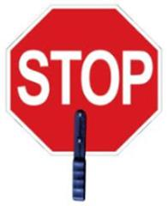

# Thank you!

To our wonderful   
Crossing Guard:

We wanted to STOP and thank you for all that you do!!

Thank you for helping us cross the street and keeping us safe every day!!



s